

ICT Theory
BS CYFS 2025
Assignment # 3
Name: Ibrahim Bin Arif
Roll no: 2503541

Submitted to : Mrs. Laraib Javaid

Table of Contents:
Making Web Page (Html Code) : 3
CSS Code : 4
4
JavaScript Code : 5
Web Page Output: 5

Making Web Page (Html Code) :
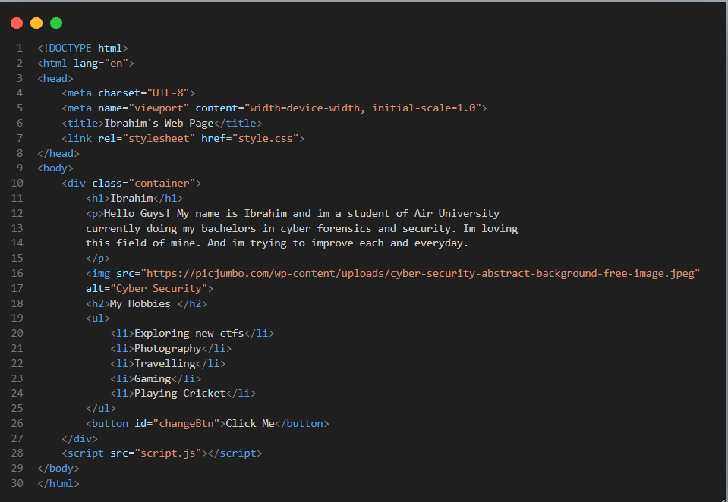

CSS Code :

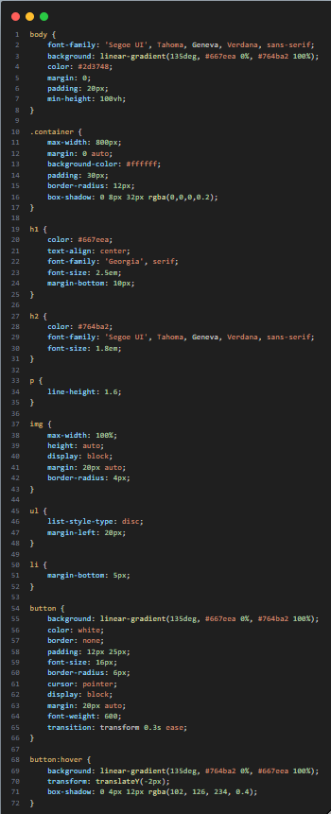

JavaScript Code :
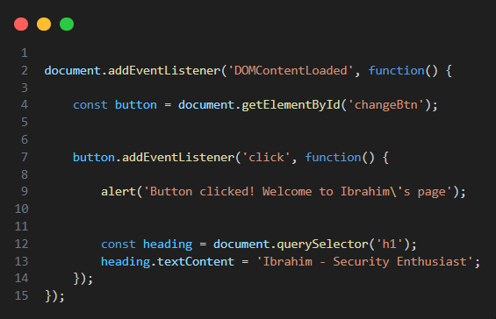

Web Page Output:
